CS 208

Spring 2016

Design Artifacts

Chemistry Lab Inventory Management System (CLIMS)

NAME | DESIGNATION | SIGNATURE | DATE
Aakash Handa | Developer
Akash Kumar | Developer
Shubha Neema | Developer
Vishal Nemade | Developer

Advisor: Dr. Abhishek Srivastava
Department of Computer Science
Indian Institute Of Technology, Indore

Chemistry Lab Inventory Management System

Index

1. Context Diagram

2. Use Case Diagram

3. Class Diagram

4. Sequence Diagram
4.1 Student Sequence Diagram
4.2 Team Leader Sequence Diagram
4.3 Research Head Sequence Diagram
4.4 Admin Sequence Diagram

5. Behavioral Diagram(DFD)

1. Context Diagram

2. Use Case Diagram

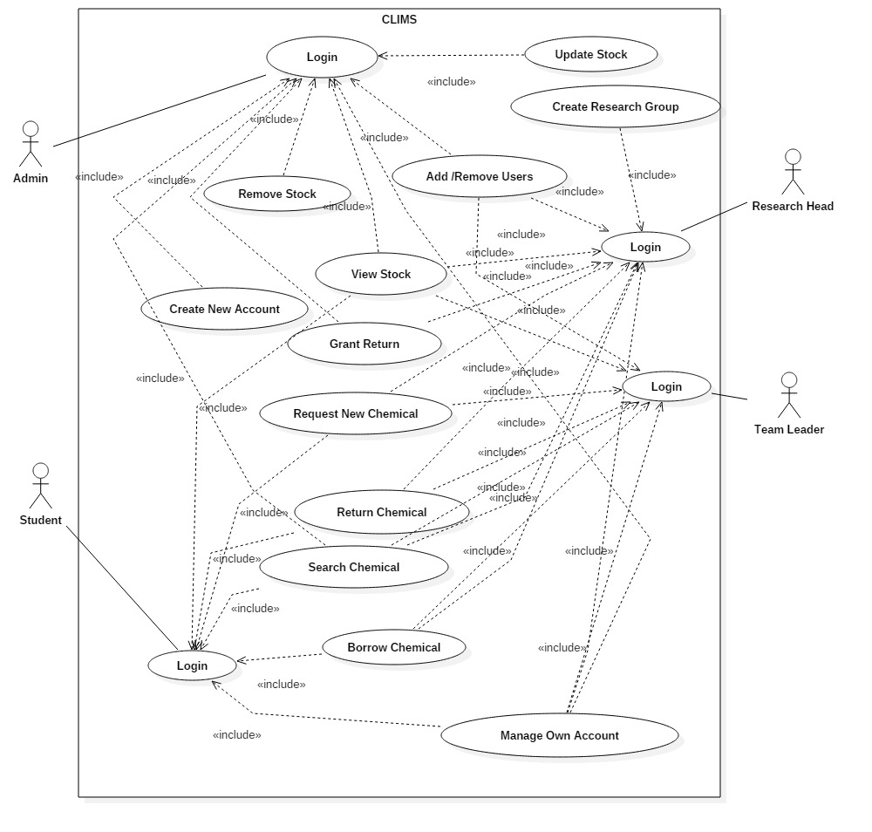

3. Class Diagram

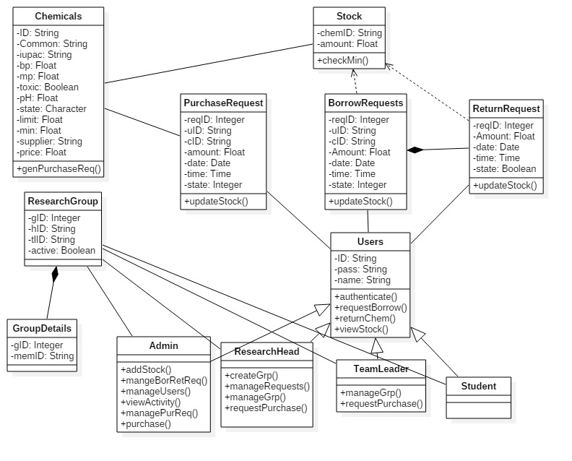

4. Sequence Diagram
4.1 Student Sequence Diagram

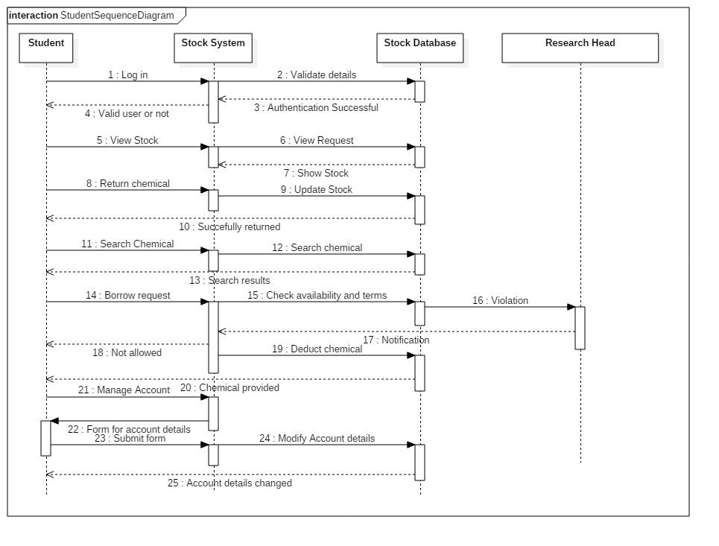

4.2 Team Leader Sequence Diagram
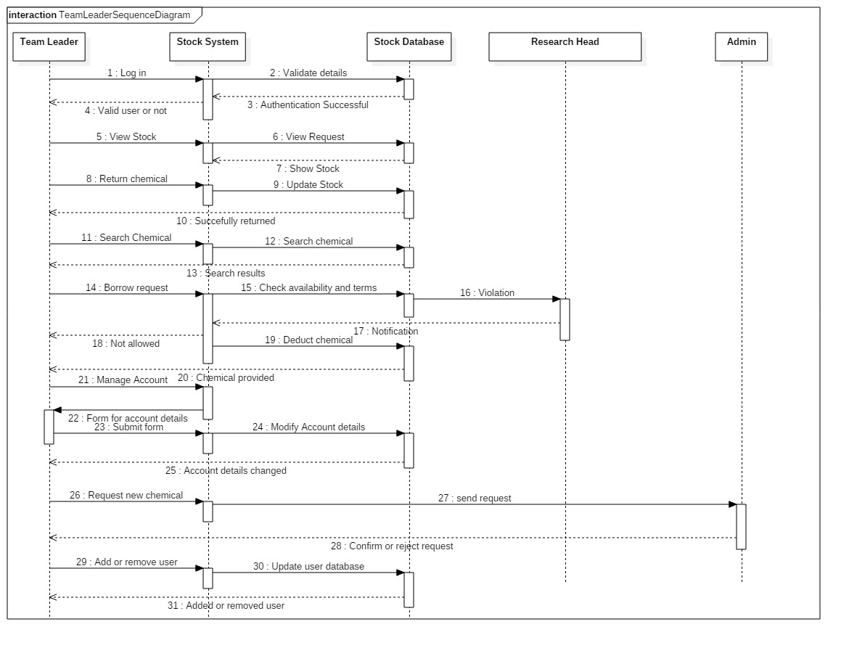

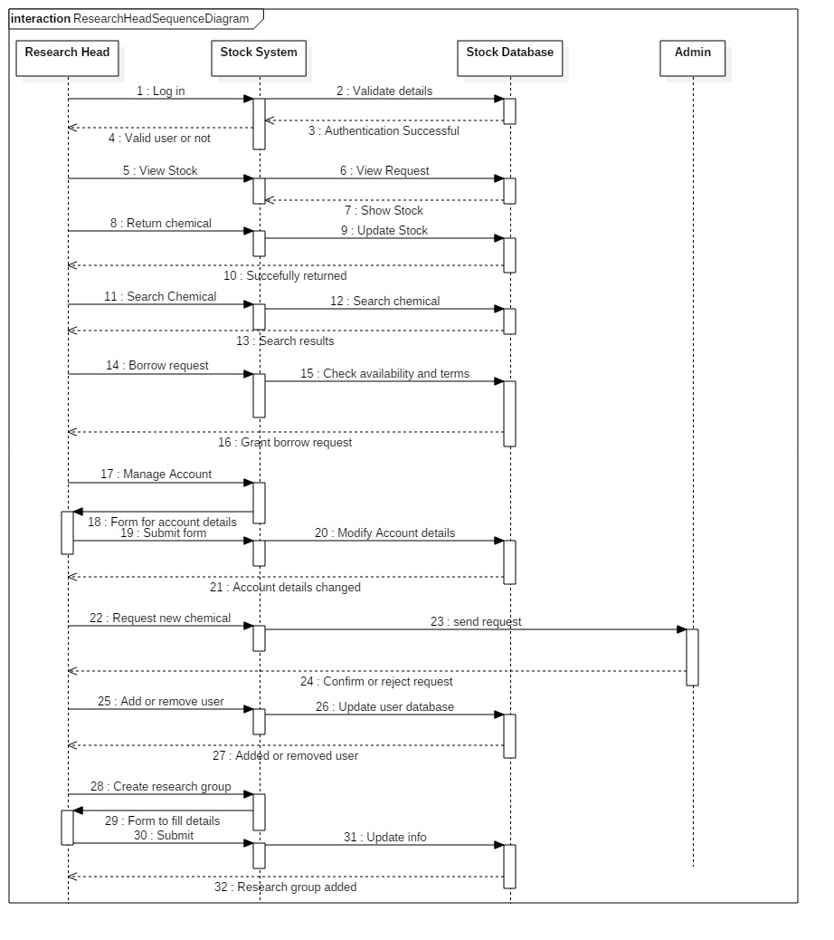
4.3 Research Head Sequence Diagram

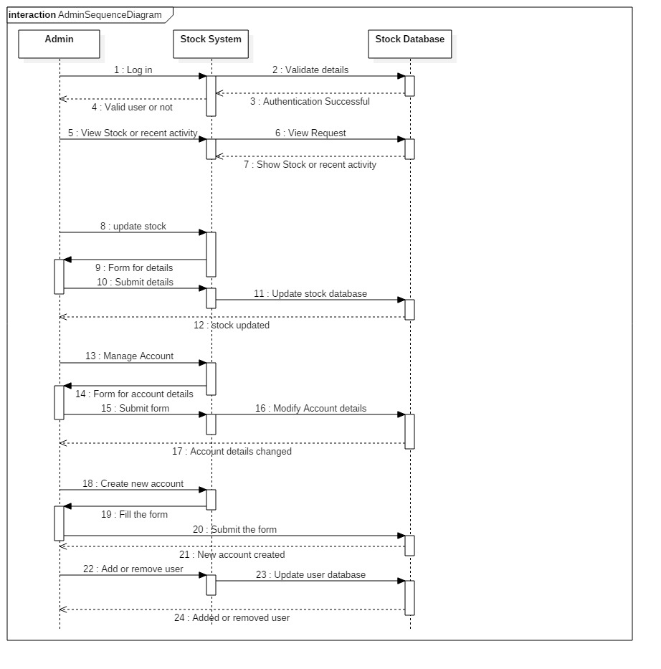
4.4 Admin Sequence Diagram

5. Behavioral Diagram(DFD)

